EXPERIMENT 25
Create a new GitHub repository for a personal project. Initialize the
repository with a README.md file. Then, clone the repository to
your local machine, make some changes to the README.md (e.g.,
add a project description), and push the changes back to GitHub.
Tasks:
• Create a GitHub repository.
• Clone the repository to your local machine.
• Edit the README.md file.
• Stage, commit, and push your changes to GitHub.
Step 1: Created a new GitHub repository named my-project.
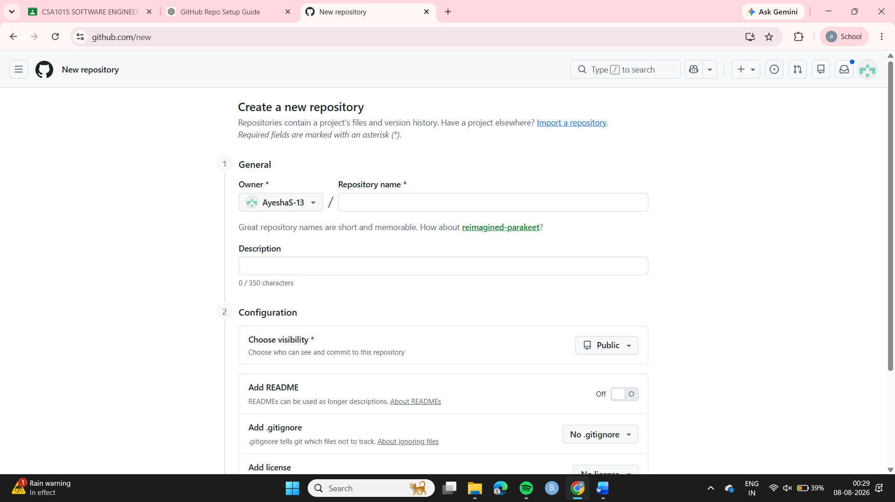
Step 2: Initialized the repository with a README.md file.
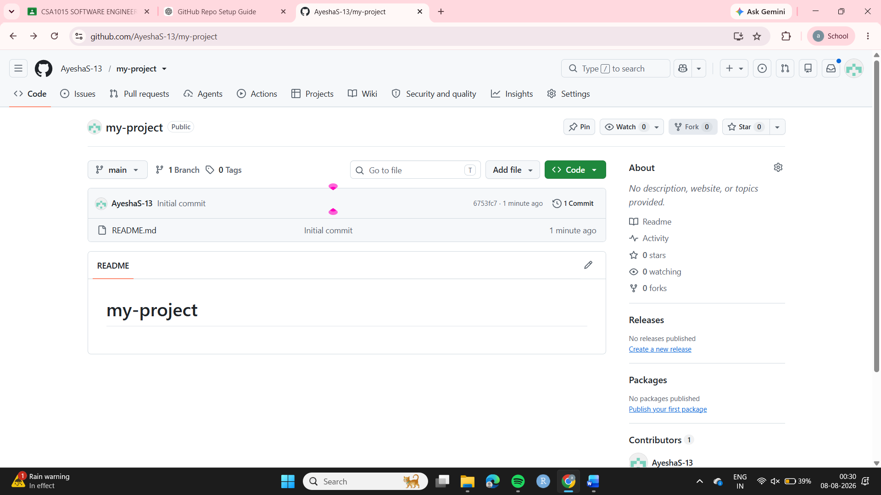

Step 3: Cloned the repository to the local machine using:
git clone <repository-url>
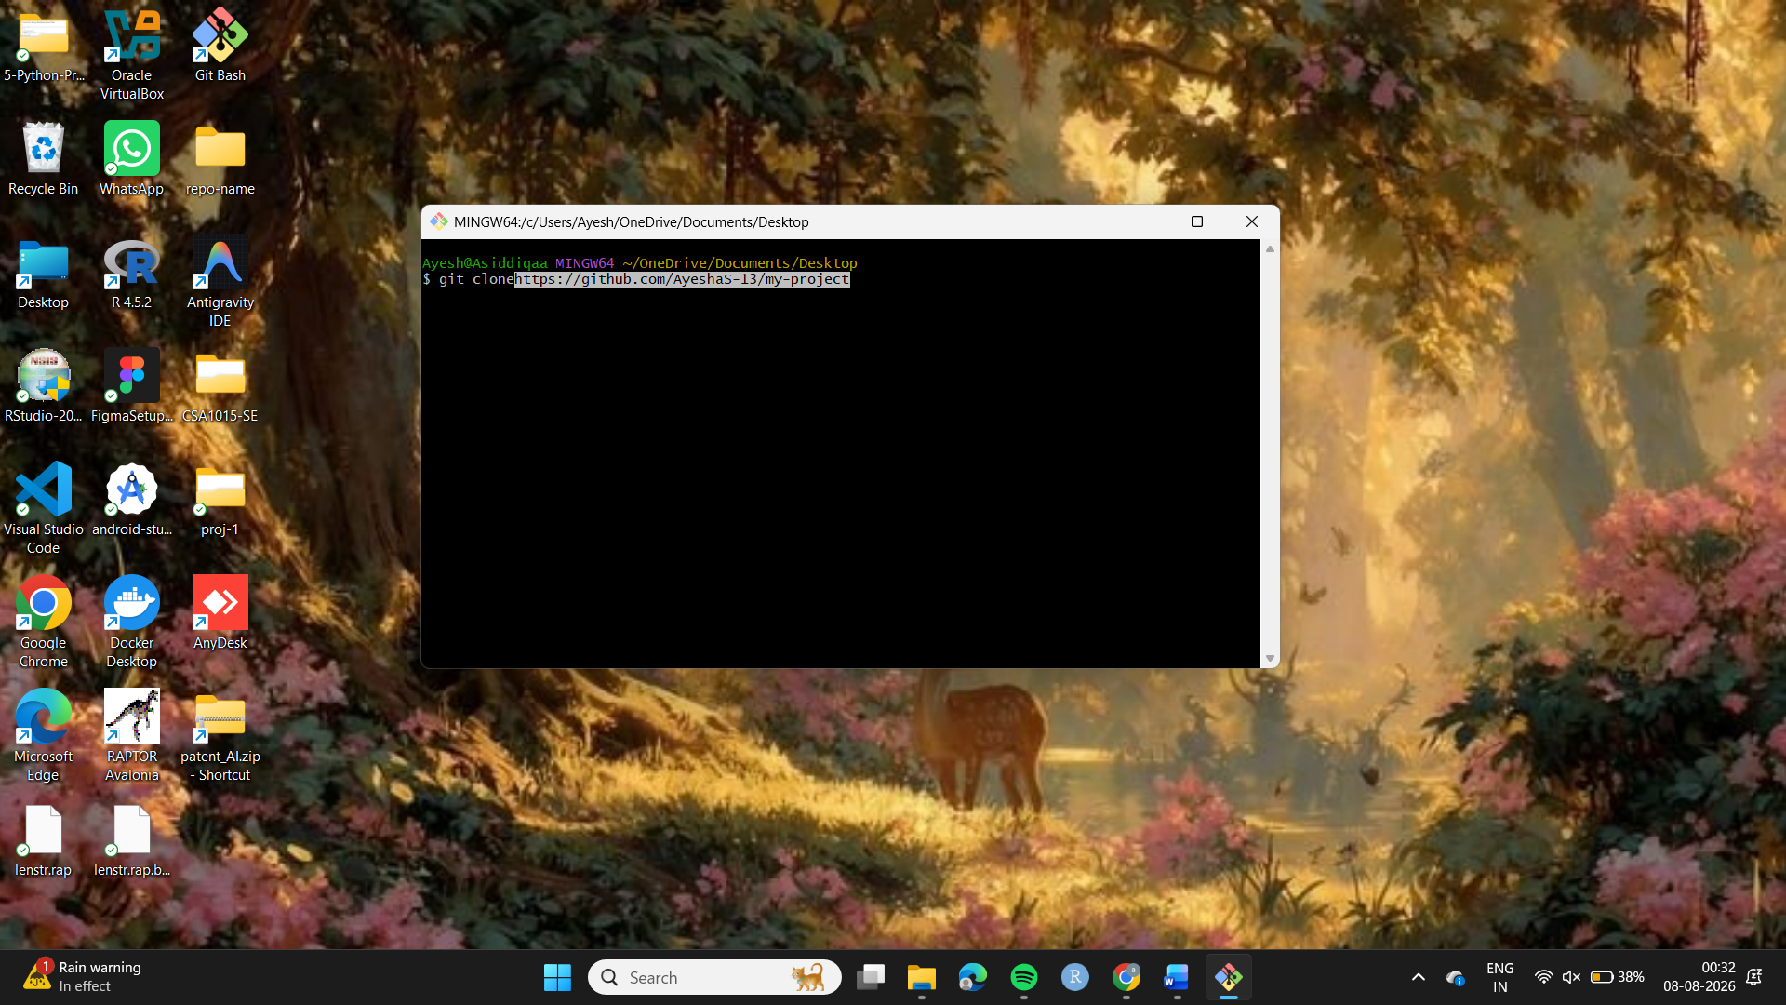
Step 4: Navigated into the repository:
cd my-project

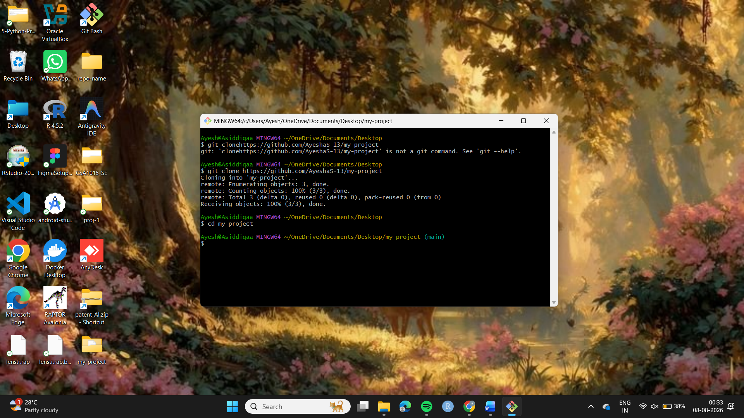
tep 5: Edited README.md and added the project title and description.
Step 6: Checked the modified files using:
git status
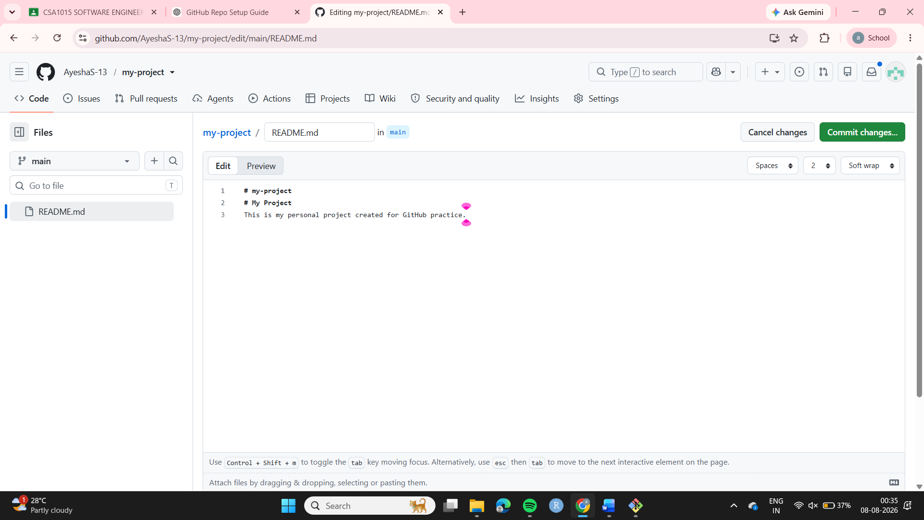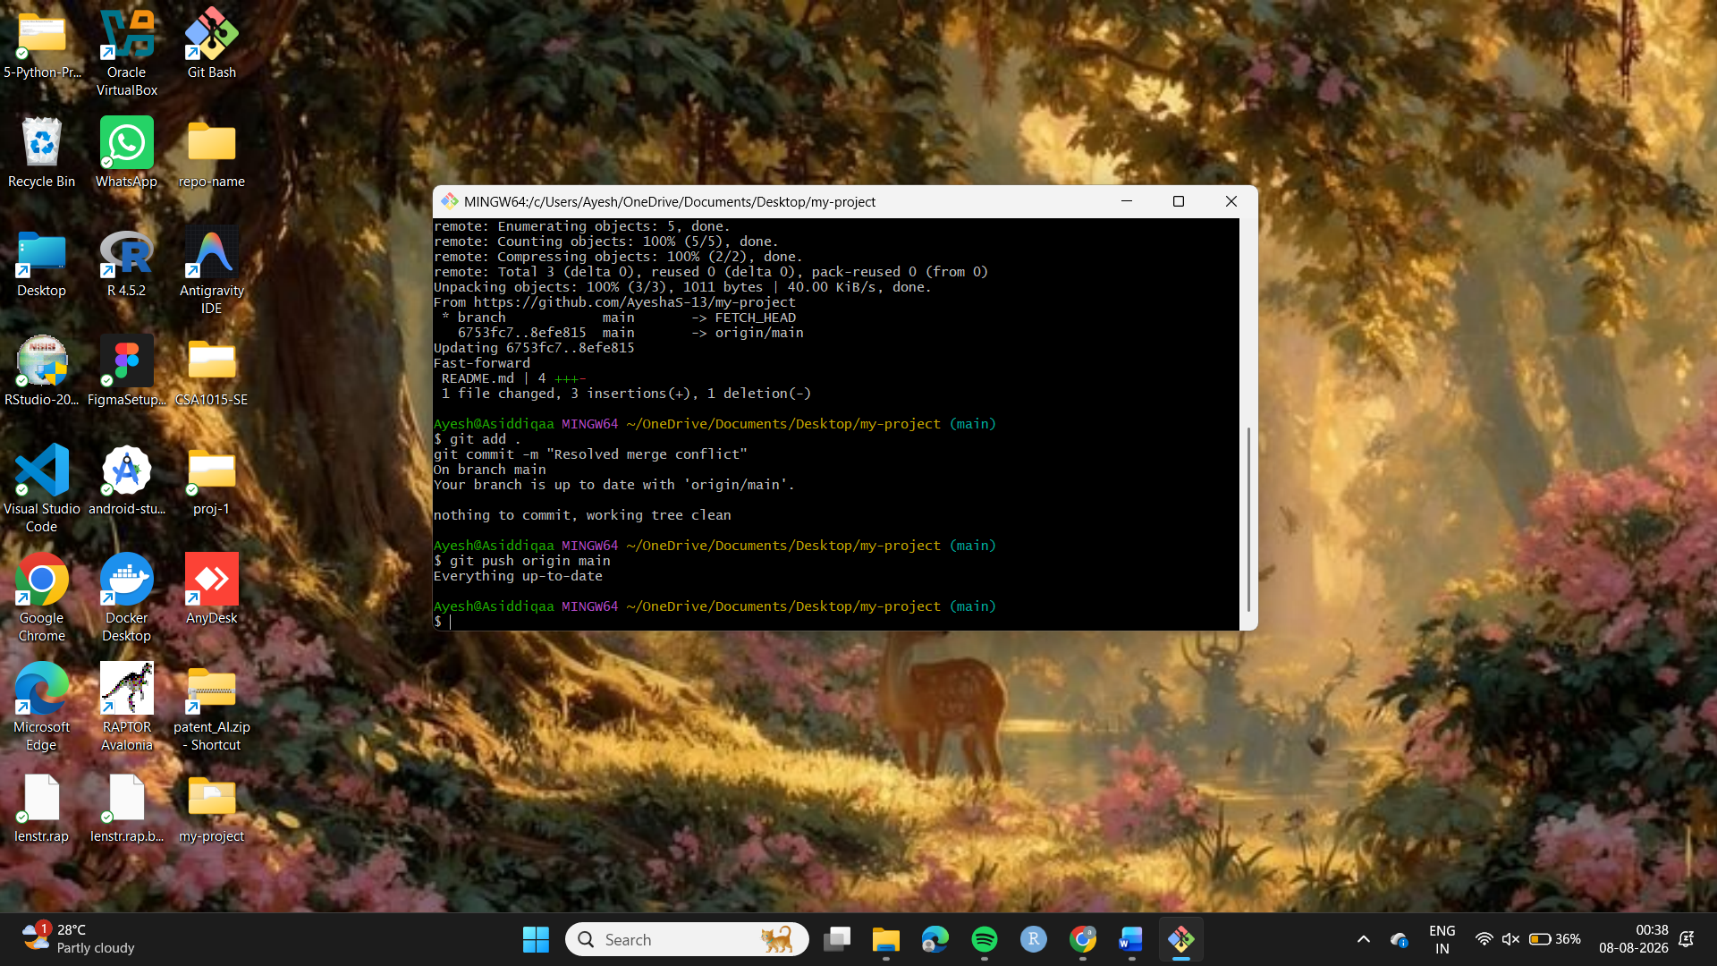
Step 9: Pushed the changes to GitHub: git push origin main Step 10: Verified the updated README on GitHub.
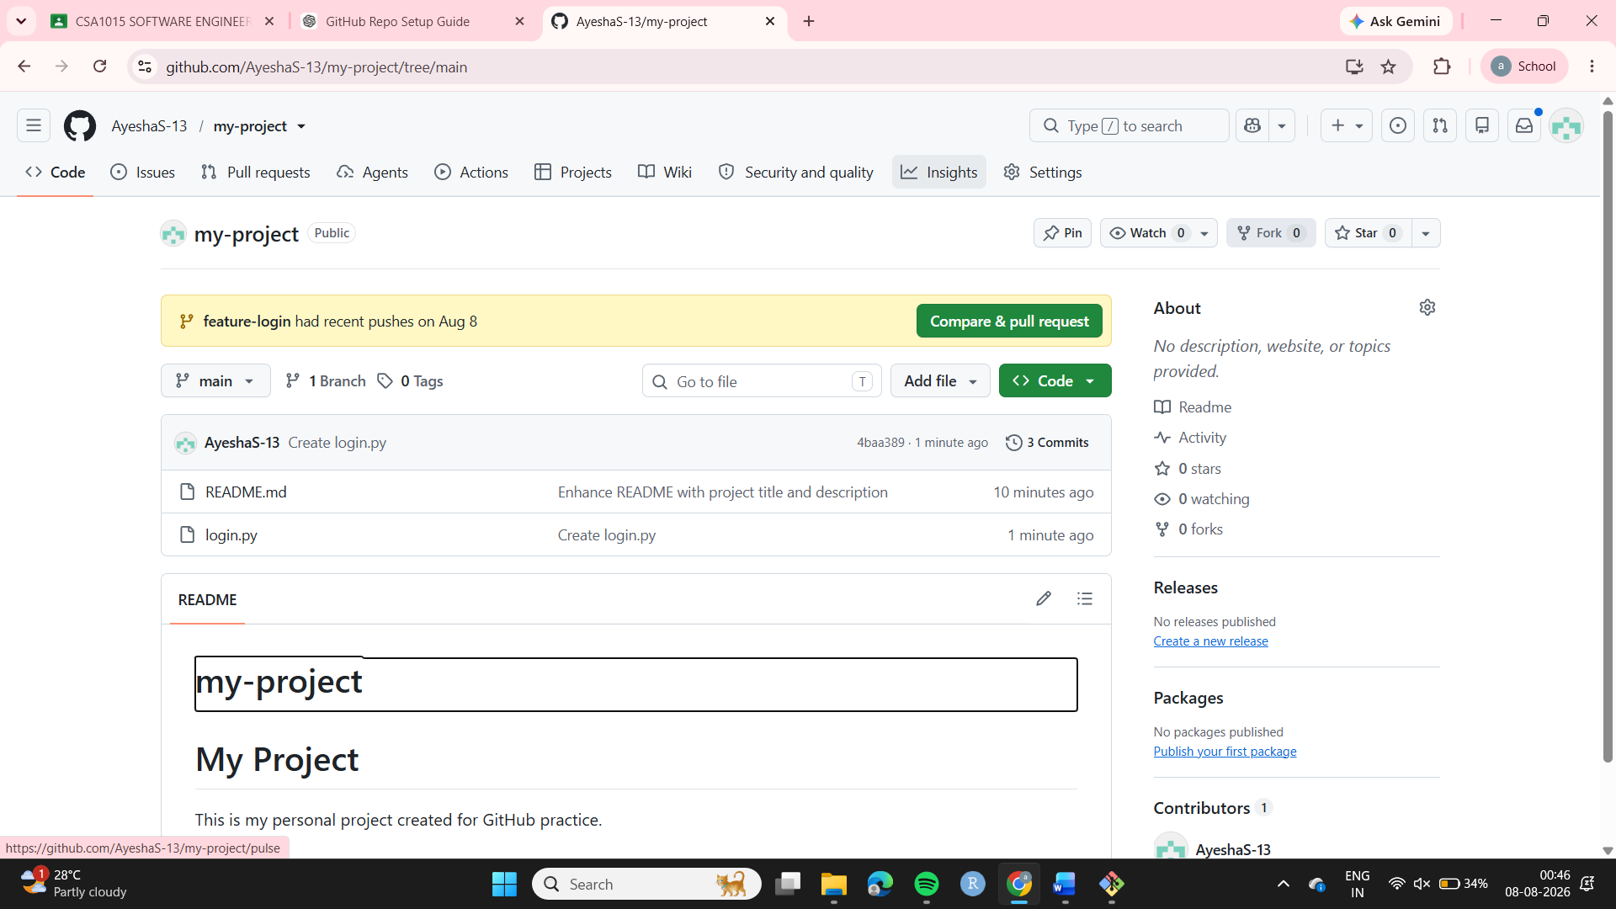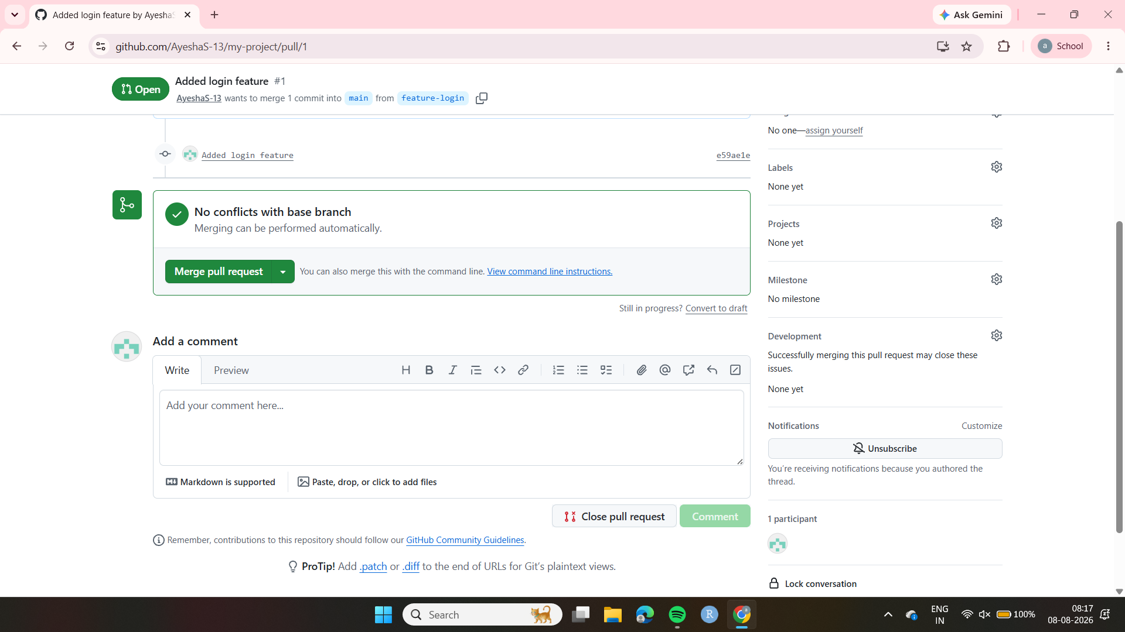
Step 11:Pull the Merged Changes to Local Machine.
